[Networking]
[Dr.Hasan ِAlrefai]

1/26/2026
Mohammed Nairoukh
[2410205]

- What is a Sunnet mask ?
- In IP networking a subnet mask is a 32-bit value that splits an IP address into two parts :
- Network segment network that the gadget is linked to
- The host section is the specific device on that network .
- The subnet mask and IP address work together to determine if two devices are on the same network or different networks .
- Example
- The IP address is 192.168.1.10 and subnet mask is 255.255.255.0 / 24 . This suggest that the network segment is 192.168.1 and 10 the part about the host
- There a advantages to using subnet mask
- Break up large networks into smaller , easier-to-manage subnets.
- Reduce network congestion
- Increase security and performance
- Select if you want to send data within or outside of the network .
- Without a subnet mask , devices couldn’t differentiate between local and remote IP addresses .
- Why do we need a default gateway ?
- The equipment (often a router ) that links a local networks , including the internet , is known as the default gateway .
- When a gadget wishes to speak :
- Data is sent directly if the target IP is on the same network .
- The data is sent to the default gateway if the destination IP is not on the network .
- How does the router enable communication ?
- A router is a networking device that forward data between several networks .
- The router facilitates communication through :
- Getting data packets from a gadget
- Examining the IP address of the destination
- Examining its routing table
- Selecting the optional route for packet forwarding
- Transferring the package to its intended location
- Among a routers primary functions are :
- Linking disparate subnets
- Serving as the gateway by default
- Packet forwarding across networks
- Keeping broadcast domains apart
- Making the internet accessible
- Screenshot :
- 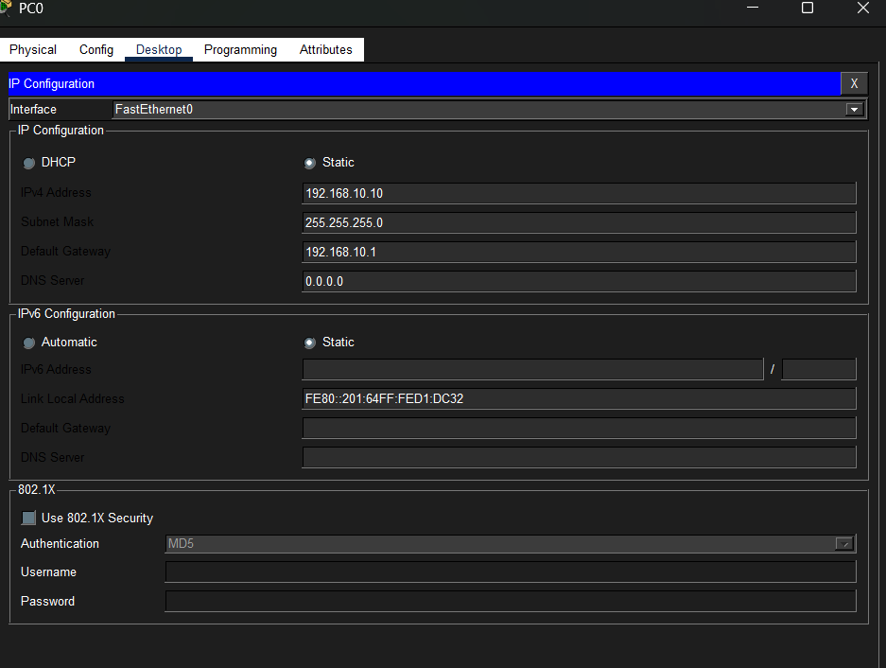
- 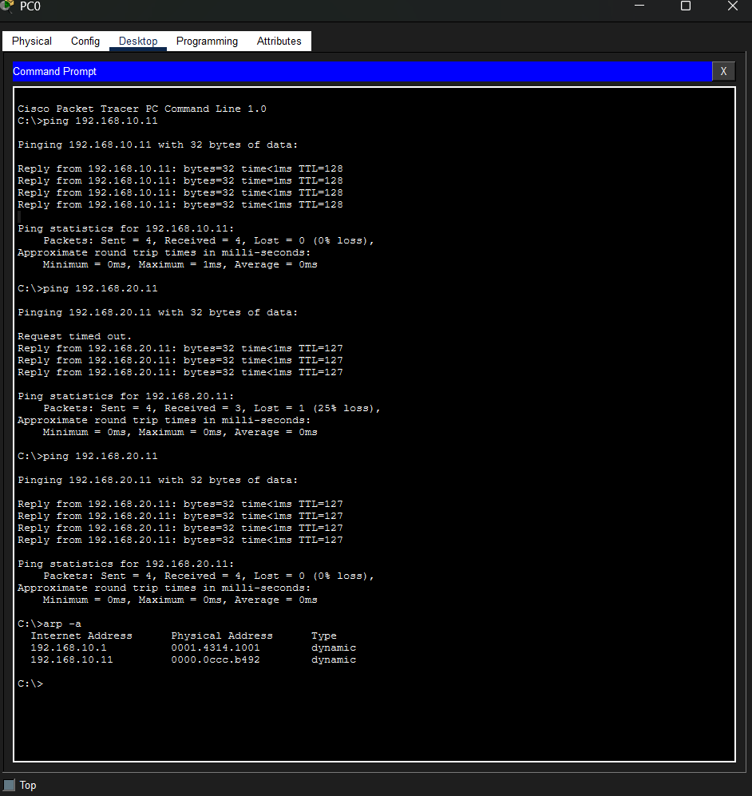
- Conclusion
- In networking , communication is made possible by the subnet mask , router , and default gateway . The router effectively forwards data between networks , default gateway offers a conduit beyond the local network , and the subnet mask establishes network boundaries . They serve as the cornerstone of contemporary IP networking .

